ABSTRACT
- "Blind Man Shoe's" Shoes for blind men help or assist optically handicapped persons to reach their respective terminus
- . It presents a working conceptual model to provide a clever automated wearable device for blind people
- . The structure is proposed to offer overall solutions which include artificial vision and object detection.
- Ultrasonic sensors help in calculating the distance of the hurdles lying in the path of blind person.
- This device helps in providing the best available track to the user in the form of vibration.
- The sensors are integrated with the shoe so that the blind person can not only detect obstacles in front but also detect the presence of any major obstacles on the way.

Table of contents

Topics. Page No
- Certificate 2
- ACKNOWLEDGEMENT 3
- ABSTRACT 4
- USED COMPONENTS WITH PRICE 6
- CHAPTER - I
  - INTRODUCTION 7
  - BASIC BLOCK DIAGRAM 8
  - CIRCUIT DIAGRAM 9
6 . CHAPTER - II
- HARDWARE COMPONENTS DESCRIPTION 11
  - Arduino Uno R3
  - ULTRASONIC SENSOR
  - LITHIUM ION BATTERY
  - VIBRATOR MOTOR
  - RELAY 7.CHAPTER - III
- SOFTWARE DESCRIPTION 18
  - ARDUINO IDE
  - CODE
- CHAPTER - IV 24
  - RESULT
    - REAL TIME PHOTOS
  - APPLICATION
- CHAPTER - V 25
  - CONCLUSION
  - REFERENCE LINKS

Used components
- Controller Components

Arduino Uno R3

- Sensing Components

Ultrasonic sensor HC-SR-04.

- Other Components

HW Batteries
  - Switch's
  - Shoes

CHAPTER - I

INTRODUCTION
285 million people are estimated to be visually impaired worldwide:39 million are blind and 246 have low vision ,about 90% of the world's visually impaired live in low-income settings where 82% of people living with blindness are aged 50 and above. Globally, uncorrected refractive errors are the main cause of moderate and severe visual impairment;cataracts remain the leading cause of blindness in middle- and low-income countries The number of people visually impaired from infectious diseases has reduced in last 20 years according to global estimates work and 80% of all visual impairment can be prevented or cured.(World Health Organization, 2017)(Parentcenterhub.org,2017)
The smart shoe uses ultrasound sensors on the toe to warn blind users of obstacles in their path. It can detect potential obstacles located up to one meters in front of the user. The wearer is then warned by haptic (vibration).The vibration feedback is provided directly in the shoe, which allows you to feel if there is an obstacle in front of you. The acoustic feedback is provided

The shoes will incorporate an ultrasonic sensor that emits high-frequency sound waves, which bounce off nearby objects and are detected by the sensor. The sensor data will be processed using a microcontroller, which will then alert the wearer of the presence of obstacles through a vibration motor. The shoes will be designed to be comfortable and stylish, with a focus on durability and functionality. The project has the potential to greatly improve the mobility and independence of visually impaired individuals by providing them with a tool to navigate their surroundings with greater ease and confidence.

BASICS BLOCK DIAGRAM

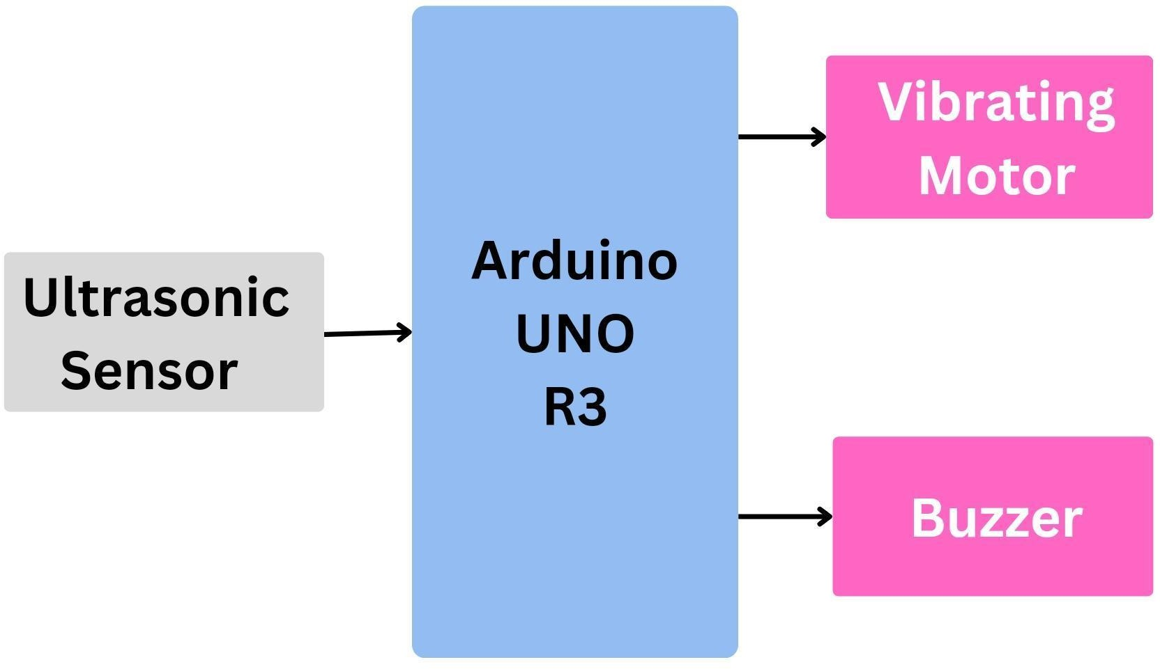

CIRCUIT DIAGRAM

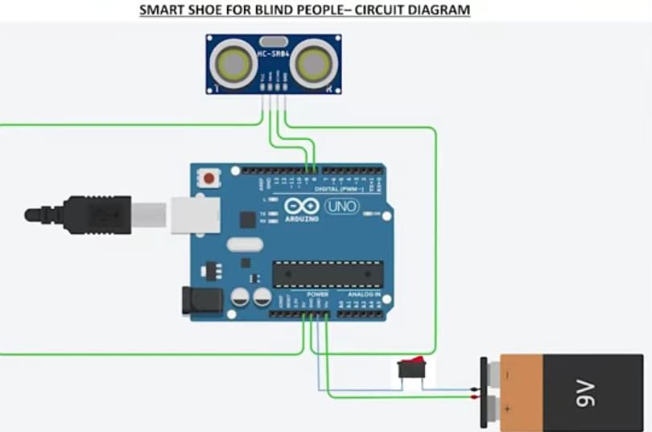

CHAPTER - II

HARDWARE COMPONENTS DESCRIPTION
Here we have used an Ultrasonic sensor for sensing obstacles .A Arduino uno r3 for controlling all components and for charging the Li-ion battery. Vibrator which gives intimation to the user.

ARDUINO UNO R3

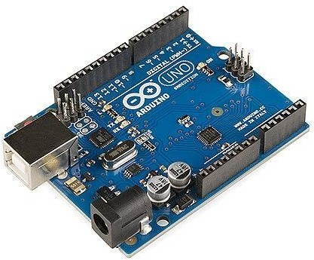

Arduino UNO r3 board view
The Arduino Uno is an open-source microcontroller board based on the Microchip ATmega328P microcontroller and developed by Arduino.cc and initially released in 2010. The board is equipped with sets of digital and analog input/output (I/O) pins that may be interfaced to various expansion boards (shields) and other circuits.The board has 14 digital I/O pins (six capable of PWM output), 6 analog I/O pins, and is programmable with the Arduino IDE (Integrated Development Environment), via a type B USB cable. It can be powered by a USB cable or a barrel connector that accepts voltages between 7 and 20 volts, such as a rectangular 9-volt battery. It is similar to the Arduino Nano and Leonardo.The hardware reference design is distributed under a Creative Commons Attribution Share-Alike 2.5 license and is available on the Arduino website. Layout and production files for some versions of the hardware are also available.

The word "uno" means "one" in Italian and was chosen to mark a major redesign of the Arduino hardware and software] The Uno board

was the successor of the Duemilanove release and was the 9th version in a series of USB-based Arduino boards. Version 1.0 of the Arduino IDE for the Arduino Uno board has now evolved to newer releases.The ATmega328 on the board comes pre programmed with a bootloader that allows uploading new code to it without the use of an external hardware programmer.While the Uno communicates using the original STK500 protocol, it differs from all preceding boards in that it does not use a FTDI USB-to-UART serial chip. Instead, it uses the Atmega16U2 (Atmega8U2 up to version R2) programmed as a USB-to-serial converter.

The Arduino project started at the Interaction Design Institute Ivrea (IDII) in Ivrea, Italy. At that time, the students used a BASIC Stamp microcontroller, at a cost that was a considerable expense for many students. In 2003, Hernando Barragán created the development platform Wiring as a Master's thesis project at IDII, under the supervision of Massimo Banzi and Casey Reas, who are known for work on the Processing language. The project goal was to create simple, low-cost tools for creating digital projects by non-engineers.
The Wiring platform consisted of a printed circuit board (PCB) with an ATmega168 microcontroller, an IDE based on Processing, and library functions to easily program the microcontroller.[10] In 2003, Massimo Banzi, with David Mellis, another IDII student, and David Cuartielles, added support for the cheaper ATmega8 microcontroller to Wiring. But instead of continuing the work on Wiring, they forked the project and renamed it Arduino. Early arduino boards used the FTDI USB-to-UART serial chip and an ATmega168.[10] The Uno differed from all preceding boards by featuring the ATmega328P microcontroller and an ATmega16U2 (Atmega8U2 up to version R2) programmed as a USB-to-serial converter.
LED: There is a built-in LED driven by digital pin 13. When the pin is high value, the LED is on, when the pin is low, it is off.
VIN: The input voltage to the Arduino/Genuino board when it is using an external power source (as opposed to 5 volts from the USB connection or other regulated power source). You can supply voltage through this pin, or, if supplying voltage via the power jack, access it through this pin.
5V: This pin outputs a regulated 5V from the regulator on the board. The board can be supplied with power either from the DC power jack (7 - 20V), the USB connector (5V), or the VIN pin of the board (7-20V). Supplying voltage via the 5V or 3.3V pins bypasses the regulator, and can damage the board.
3V3: A 3.3 volt supply generated by the on-board regulator. Maximum current draw is 50 mA.
GND: Ground pins.

IOREF: This pin on the Arduino/Genuino board provides the voltage reference with which the microcontroller operates. A properly configured shield can read the IOREF pin voltage and select the appropriate power source, or enable voltage translators on the outputs to work with the 5V or 3.3V.
Reset: Typically used to add a reset button to shields that block the one on the board.[9]
Special pin functions Edit
Each of the 14 digital pins and 6 analog pins on the Uno can be used as an input or output, under software control (using pinMode(), digitalWrite(), and digitalRead() functions). They operate at 5 volts. Each pin can provide or receive 20 mA as the recommended operating condition and has an internal pull-up resistor (disconnected by default) of 20-50K ohm. A maximum of 40mA must not be exceeded on any I/O pin to avoid permanent damage to the microcontroller. The Uno has 6 analog inputs, labeled A0 through A5; each provides 10 bits of resolution (i.e. 1024 different values). By default, they measure from ground to 5 volts, though it is possible to change the upper end of the range using the AREF pin and the analogReference() function.[9]
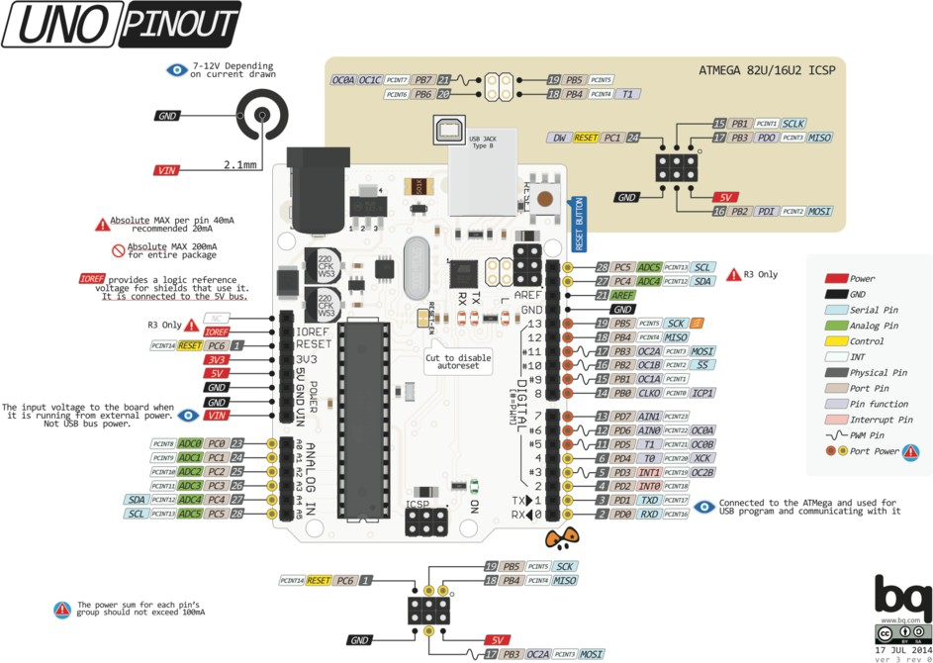

In addition, some pins have specialized functions:
- Serial / UART: pins 0 (RX) and 1 (TX). Used to receive (RX) and transmit (TX) TTL serial data. These pins are connected to the corresponding pins of the ATmega8U2 USB-to-TTL serial chip.
- External interrupts: pins 2 and 3. These pins can be configured to trigger an interrupt on a low value, a rising or falling edge, or a change in value.
- PWM (pulse-width modulation): pins 3, 5, 6, 9, 10, and 11. Can provide 8-bit PWM output with the analogWrite() function.

- SPI (Serial Peripheral Interface): pins 10 (SS), 11 (MOSI), 12 (MISO), and 13 (SCK). These pins support SPI communication using the SPI library.
- TWI (two-wire interface) / I²C: pin SDA (A4) and pin SCL (A5). Support TWI communication using the Wire library.
- AREF (analog reference): Reference voltage for the analog inputs

Technical specifications
Microcontroller:
- IC: Microchip ATmega328P[9]
- Clock Speed: 16 MHz on Uno board, though IC is capable of 20MHz maximum at 5 Volts
- Flash Memory: 32 KB, of which 0.5 KB used by the bootloader
- SRAM: 2 KB
- EEPROM: 1 KB
- UART peripherals: 1
- I2C peripherals: 1
- SPI peripherals: 1
- Operating Voltage: 5 Volts
- Digital I/O Pins: 14
11. PWM Pins: 6 (Pin # 3, 5, 6, 9, 10 and 11)[11]
- Analog Input Pins: 6
- DC Current per I/O Pin: 20 mA
- DC Current for 3.3V Pin: 50 mA
- Length: 68.6 mm
- Width: 53.4 mm
- Weight: 25 g
- ICSP Header: Yes

Power Pins
- 5V - This is 5v out from the USB port. You can also use this as a voltage input but you must have some sort of diode (, signal, power) between your external power source and this pin with anode to battery, cathode to 5V pin.
- 3V3 - This is the regulated output from the onboard regulator. You can draw 700mA
- GND - Power/data/signal ground

Battery Usage

The Arduino uno is capable of using a 5 V lithium battery as the power supply input.

Ultrasonic snsore

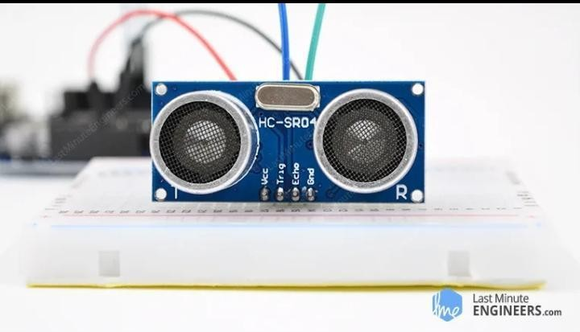

Give your next Arduino project bat-powers with the HC-SR04 Ultrasonic Distance Sensor that can report the range of objects up to 13 feet away. This is a good thing to know when you’re trying to save your robot from hitting a wall.
They are low power (suitable for battery operated devices), affordable, easy to interface and extremely popular with hobbyists.An HC-SR04 ultrasonic distance sensor actually consists of two ultrasonic transducers.
One acts as a transmitter that converts the electrical signal into 40 KHz ultrasonic sound pulses. The other acts as a receiver and listens for the transmitted pulses. When the receiver receives these pulses, it produces an output pulse whose width is proportional to the distance of the object in front.This sensor provides an Arduino or any other 5V logic microcontroller.
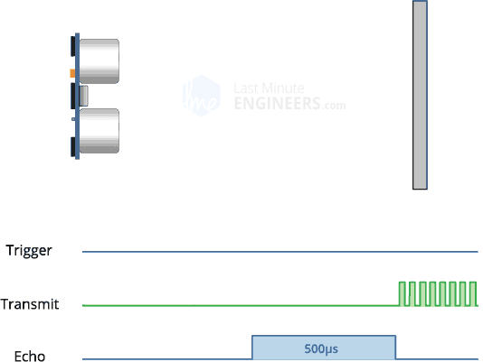
Here we have the value of time i.e. 500 µs and we know the speed. Of course it’s the speed of sound! It is 340 m/s. To calculate the distance we need to convert the speed of sound into cm/µs. It is 0.034 cm/μs. With that information we can

now calculate the distance !But we’re not done yet! Remember that the echo pulse indicates the time it takes for the signal to be sent and reflected back. So to get the distance, you have to divide your result by two.

Li-ion Battery

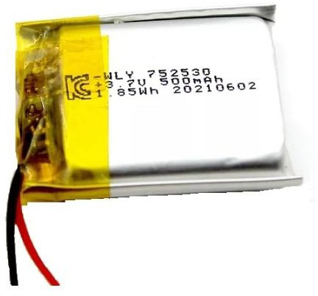

A lithium-ion or Li-ion battery is a type of rechargeable battery which uses the reversible reduction of lithium ions to store energy. The anode (positive electrode) of a conventional lithium-ion cell is typically graphite made from carbon. The cathode (negative electrode) is typically a metal oxide. The electrolyte is typically a lithium salt in an organic solvent.It is the predominant battery type used in portable consumer electronics and electric vehicles. It also sees significant use for grid-scale energy storage and military and aerospace applications. Compared to other rechargeable battery technologies, Li-ion batteries have high energy densities, low self-discharge, and no memory effect (although a small memory effect reported in LFP cells has been traced to poorly made cells)

- Jumper wires
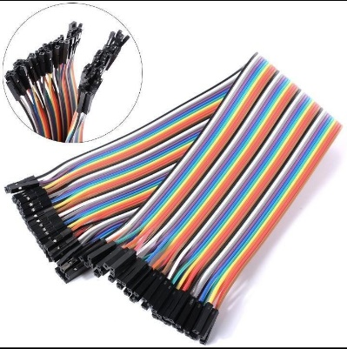
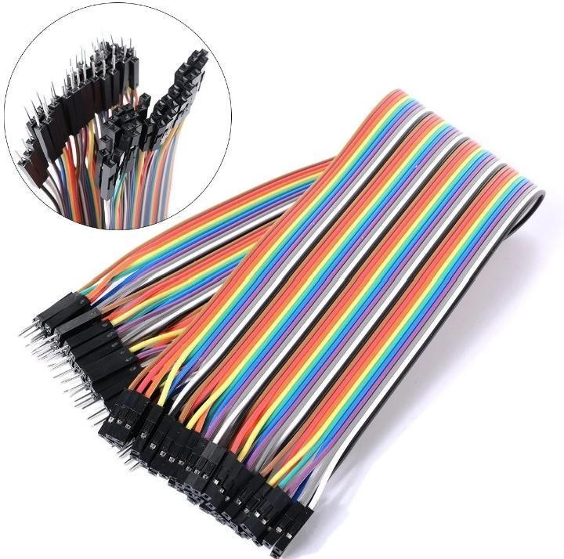
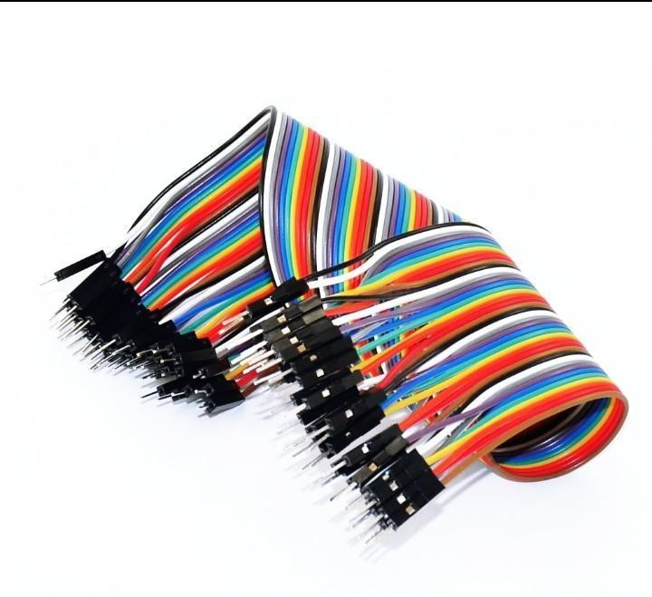

Female to Female Male to Female Male to Male

Generally, jumpers are tiny metal connectors used to close or open a circuit part. They have two or more connection points, which regulate an electrical circuit board.
Their function is to configure the settings for computer peripherals, like the motherboard. Suppose your motherboard supported intrusion detection. A jumper can be set to enable or disable it.
Jumper wires are electrical wires with connector pins at each end. They are two points in a circuit without soldering.
You can use jumper wires to modify a circuit or diagnose problems in a circuit. Further, they are best used to bypass a part of the circuit that does not contain a resistor and is suspected to be bad. This includes a stretch of wire or a switch. Suppose all the fuses are good and the component is not receiving power; find the circuit switch. Then, bypass the switch
with the jumper

CHAPTER - III

SOFTWARE DESCRIPTION

ARDUINO IDE
The Arduino IDE is an open-source software, which is used to write and upload code to the microcontroller boards. The IDE application is suitable for different operating systems such as Windows, Mac OS X, and Linux. It supports the programming languages C and C++. Here, IDE stands for Integrated Development Environment.
The program or code written in the Arduino IDE is often called sketching. We need to connect the Genuino and Arduino board with the IDE to upload the sketch written in the Arduino IDE software. The sketch is saved with the extension '.ino.'
The Arduino IDE will appear as:

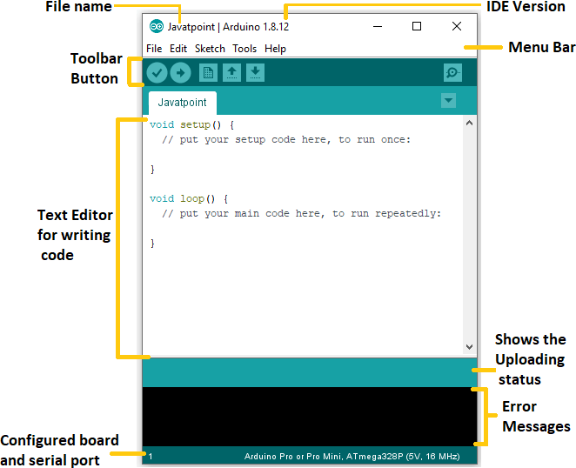

Let's discuss each section of the Arduino IDE display in detail.
- Save The save button is used to save the current sketch or code.
- It is used to create a new sketch or open a new window.
- Verify The Verify button is used to check the compilation error of the sketch or the written code.
- Serial Monitor The serial monitor button is present on the right corner of the toolbar. It opens the serial monitor.

Software setup
Navigate to Tools > Board > Arduino AVR Board and select "ARDUINO UNO ". The list of boards is a little long and you need to roll to the bottom to reach it.
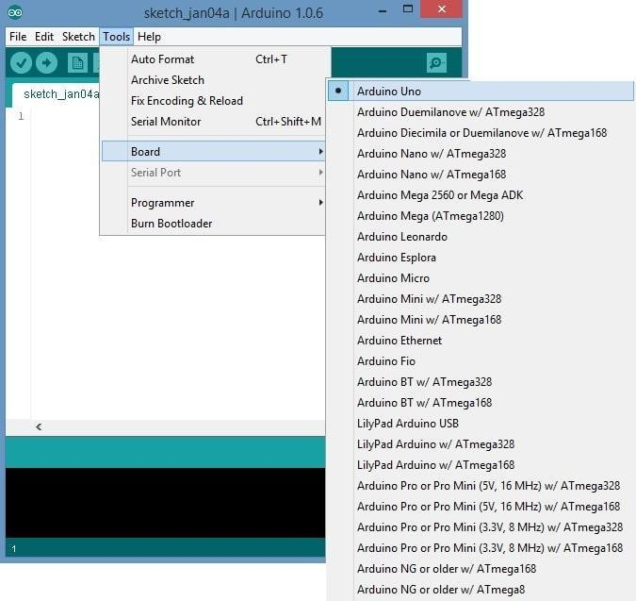

Select the appropriate port to your board
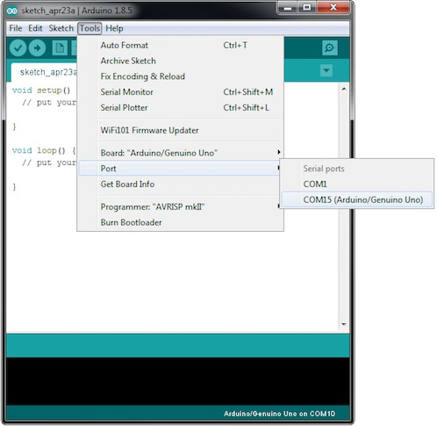

Basic Example code

To ensure that everything is properly configured, we’ll upload the most basic sketch of all – Blink!

This test uses the on-board LED. As previously mentioned in this tutorial, the D2 pin of the board is connected to the on-board LED and is user programmable.

Testing code
int ledPin = 2; void setup() {

pinMode(ledPin, OUTPUT);
}

void loop() {
digitalWrite(ledPin, HIGH); delay(500); digitalWrite(ledPin, LOW); delay(500);

}
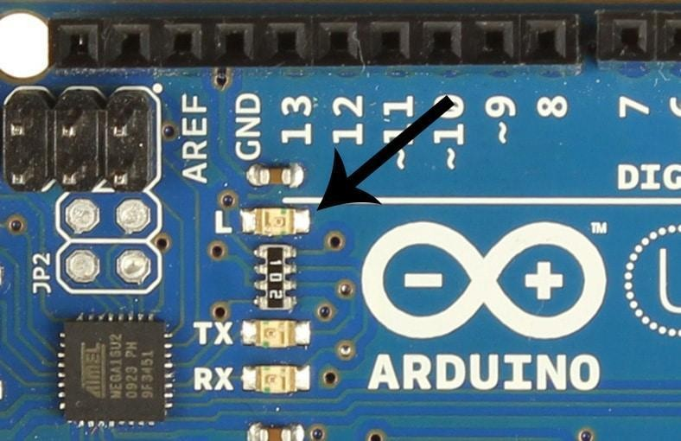
- Expected output

ALGORITHM
The following are the general steps involved in obstacle detection using Ultrasonic Sensor and detection of water in blind person paths
  - A Burst of ultrasonic pulse is sent from both ultrasonic sensors to detect the obstacle in path, this is done by putting the trigger pin of the ultrasonic sensor high for 10 microseconds.
  - The echo pulse is received using the Echo pin of the ultrasonic sensor.
  - The time duration between transmitted pulse and echo pulse is used to calculate the distance between shoe and obstacle.
  - If the obstacle detected by the forward sensor is within the distance of 30cm or less, the forward vibrating motor gets triggered.
  - If the obstacle detected by sideward sensor is Within the distance of 30cm or less, sideward vibrating motor and a buzzer will be get triggered

MAIN CODE

#define trigPin 9 // Trig Pin Of HC-SR04

#define echoPin 8 // Echo Pin Of HC-SR04

#define BUZ 13 //BUZZER

long duration, distance;

void setup()

{

pinMode(BUZ, OUTPUT);

pinMode(trigPin, OUTPUT); // Set Trig Pin As O/P To Transmit Waves

pinMode(echoPin, INPUT); //Set Echo Pin As I/P To Receive Reflected Waves

}

void loop()

{

Serial.begin(9600);

digitalWrite(trigPin, LOW);

delayMicroseconds(2);

digitalWrite(trigPin, HIGH); // Transmit Waves For 10us

delayMicroseconds(10);

duration = pulseIn(echoPin, HIGH); // Receive Reflected

Waves

distance = duration / 58.2; // Get Distance

Serial.println(distance);

delay(10);

if (distance < 15) // Condition For Absence Of Obstacle

{ // turn BUZZER ON & OFF 5 times:

for (int i=0; i<5; i++)

{

digitalWrite(BUZ, HIGH);

delay(50);

digitalWrite(BUZ, LOW);

delay(50); }

}

- RESULT

CHAPTER - IV

Real Time photo's

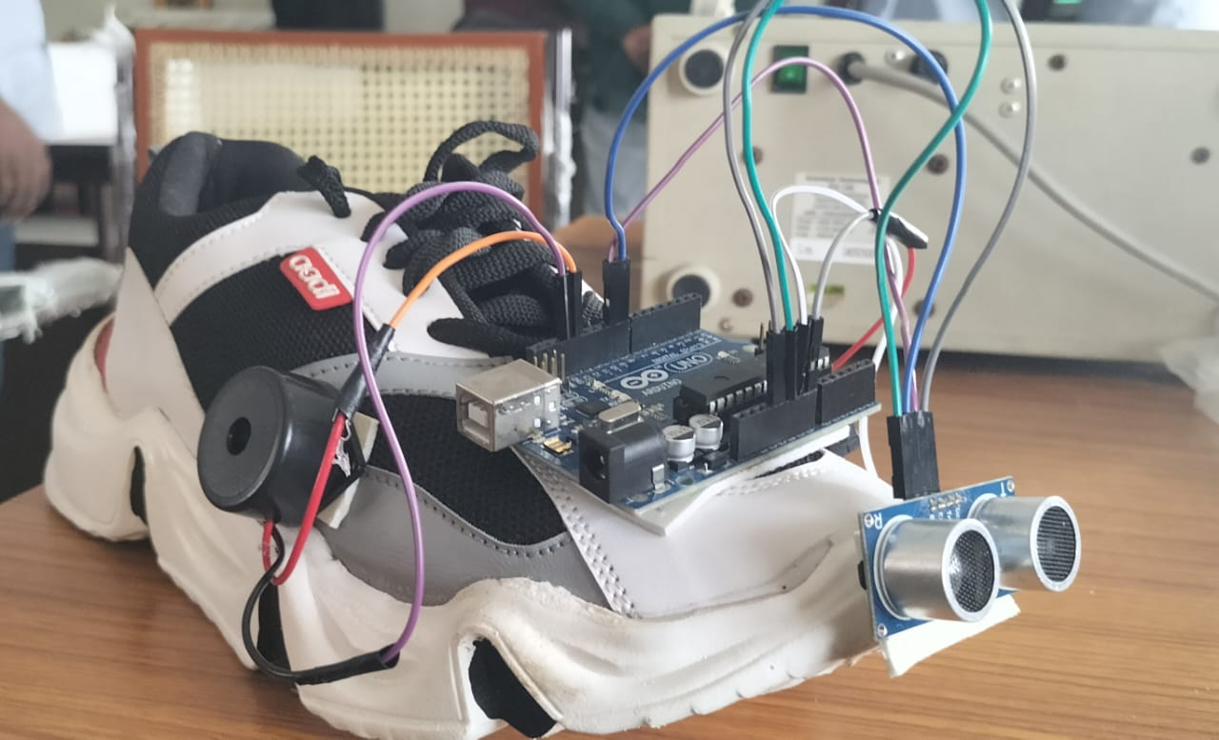

- 111Applications
- It helps the blind person to reach there destination.
- Person can identify the obstacles.

- CONCLUSION

CHAPTER - V

There is no doubt that every project has its own weaknesses. In this section, we are going to mention the weaknesses of the Blind Man Shoe's project. One of the weaknesses in our project is that it is only that the hardware is not waterproof yet.
A shoe that helps visually impaired people in walking has been designed. The shoes proposed here can be worn by visually impaired people while walking. The prototype was implemented with the minimum resources. The circuitry was kept simple
In particular this project can be improved by adding some other pieces of hardware into a device such as a Controller that fully control -ls the functionality of the hardware, by turning it on and off, connecting the device to the mobile application by Bluetooth technology, and also save -ing the current location and translating the voice commands. Another improvement is enhancing the mobile application by growing the database which allows the user to save more than one location to visit in then near future, also creating a community for visually impaired users, which allows them to interact with volunteers, and arranging possible meetings.

REFERENCE'S

- https://youtu.be/qIQvXeuyjlo?si=yFHDGpHxNLidj5Qf

